DAILY ONLINE ACTIVITIES SUMMARY

Date: |  | 23-05-2020 |  |  |  |  | Name: | Suhas Prasad shetty
Sem & Sec |  | ₈th _{B} |  |  |  |  | USN: | 4AL16CS080
 |  |  |  |  | Online Test Summary
Subject |  |  | ------
Max. Marks |  |  | ------ |  |  | Score |  | -------
 |  |  |  | Certification Course Summary
Course |  | AWS security
Certificate Provider |  |  |  | AWS |  | Duration |  |  | 50 mins
 |  |  |  |  | Coding Challenges

Problem Statement: Write a C program to display first N Triangular Numbers

Status: completed

Uploaded the report in Github | yes
If yes Repository name | suhas
Uploaded the report in slack | no

Certification Course Details :
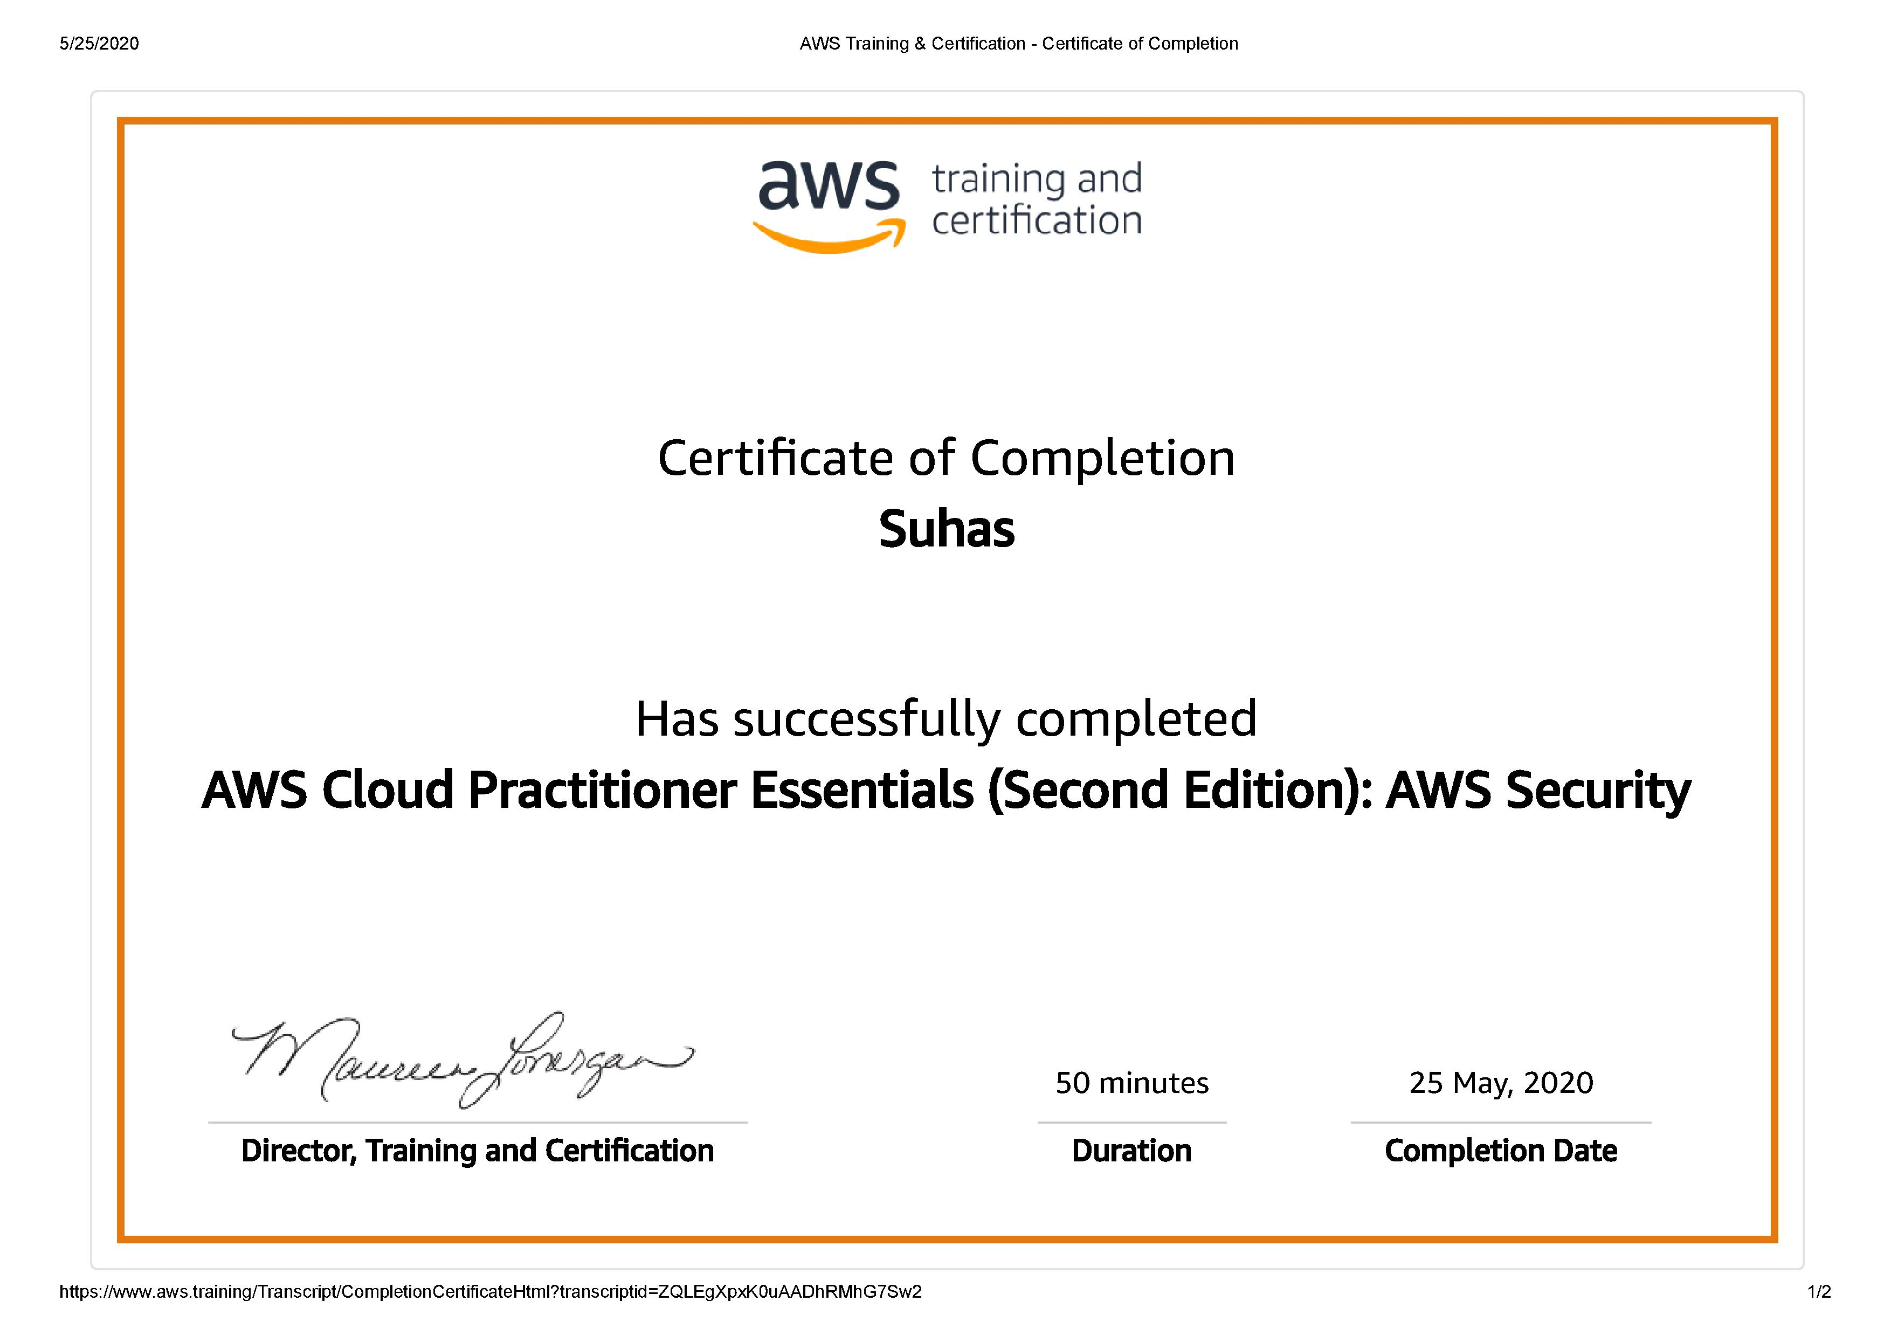

Coding Challenges Details:

PROGRAM1

#include <stdio.h>

void triangular_series(int n)

{

for (int i = 1; i <= n; i++)

printf(" %d ", i*(i+1)/2);

}

int main()

{

int n ;

printf("Enter value for n");

scanf("%d",&n);

triangular_series(n);

return 0;

}

